# Lab Manual 10

**Configuration of DNS, Http Server, DHCP on Router & Server**

**CLO 4**

Using packet tracer :

1- We connect the figure .

2- We put the IP address for each device as the following :

We have in the figure 5 networks :

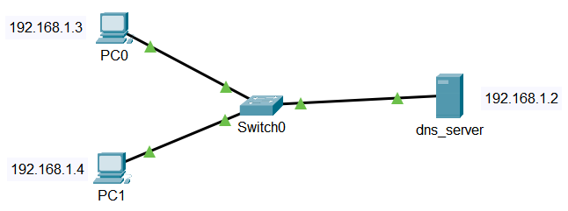

**Configure DNS service on the generic server.**

To do this, click on the server, then Click on**Services**tab. Click on **DNS server** from the menu. First  turn **ON** the DNS service, then define **names** of the hosts and their corresponding **IP addresses.**

For example, to specify the DNS entry for PC0: In the**name**and **address**fields, type:

**Name:** PC0     **Address:**192.168.1.3

Click on **add**then **save**.

Once you’re done, your DNS entries will look like this:

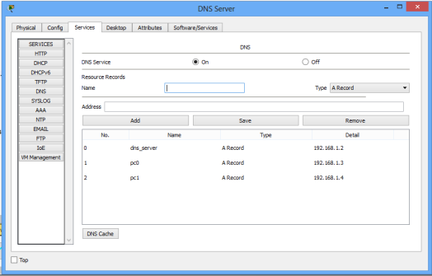

**Configuration of Http Server:**

We have to open services and click on HTTP service. This service is enabled by default and we can see that server is hosting some files already. These files are present by default and when we point the web browser to this server, this server will serve the web page to our browser.

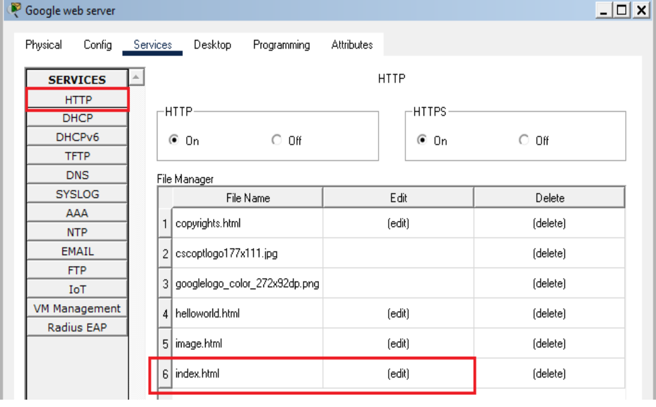

To change the content of the webpage, we have to edit the index file present in the web server.

For testing purposes, we can copy the source code of any side that you want the webserver to show and paste it into the index file. After saving the file, the web server will show sites according to the source code.

Now, we can test the web server by opening the browser on the PC and pointing it to the server.

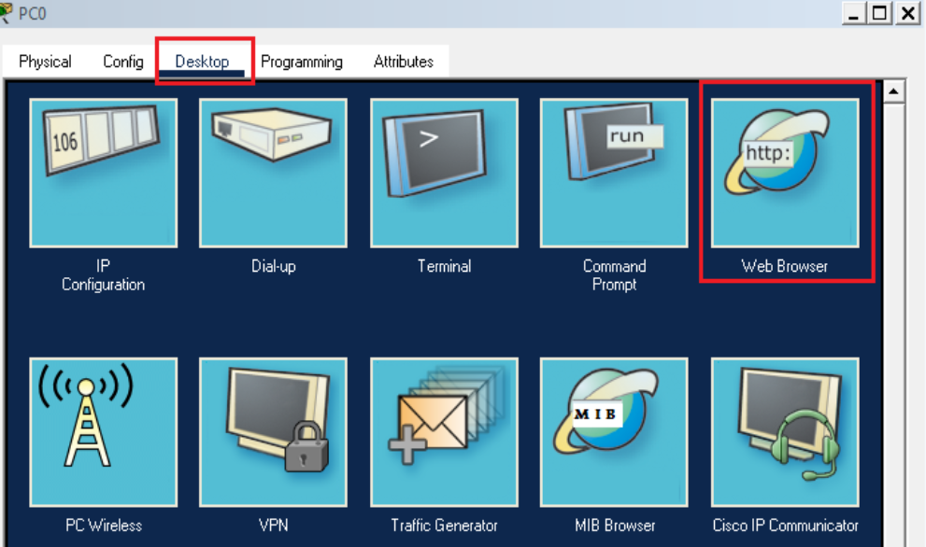

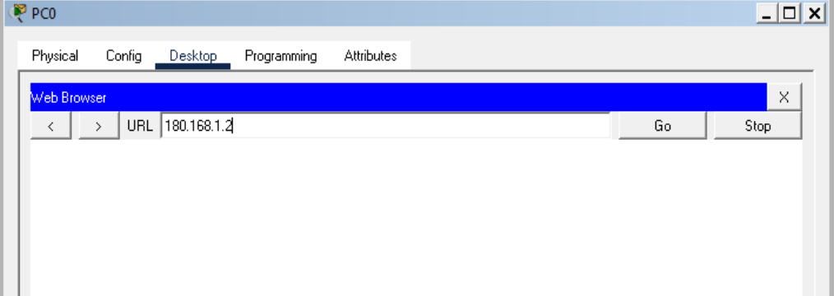

**Configuring DHCP server on a Router:**

1. Build the network topology:

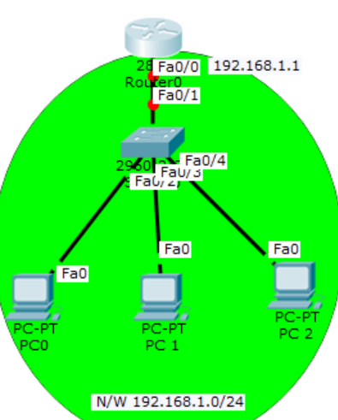

2. On the router, configure *interface fa0/0* to act as the default gateway for our LAN.

Router>enable

Router#config terminal

Router(config)#int fa0/0

Router(config-if)#ip add 192.168.1.1 255.255.255.0

Router(config-if)#no shutdown

Router(config-if)#exit

3. Configure DHCP server on the Router. In the server we will define a **DHCP pool** of IP addresses to be assigned to hosts, a **Default gateway**  for the LAN and a **DNS Server**.

Router(config)#

Router(config)#ip dhcp pool MY_LAN

Router(dhcp-config)#network 192.168.1.0 255.255.255.0

Router(dhcp-config)#default-router 192.168.1.1

Click **PC1->Desktop->IP configuration.**Then enable DHCP

**Configuring DHCP service  on a generic server in Packet Tracer:**

Build  the network topology in packet tracer

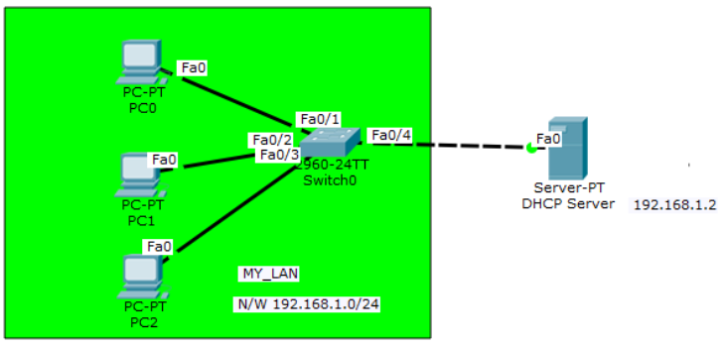

2. Configure static IP address on the server (192.168.1.2/24).

3. Now configure DHCP service on the generic server.

To do this, click on the server, then click on **Services tab**. You will pick **DHCP** on the menu. Then proceed to define the DHCP network parameters as follows:

**Pool name**: MY_LAN

**Default Gateway:**192.168.1.1

**DNS Server:**192.168.1.2

**Start IP Address:**192.168.1.0

**Subnet Mask:** 255.255.255.0

**Maximum Number of users:**256

Click on **add** then **Save.**The DHCP entry is included in the list.

Here are the configurations on the server:

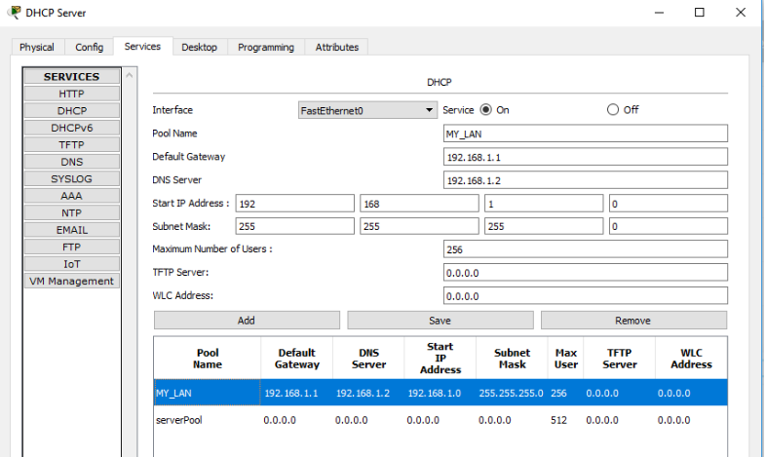

4. Finally, enable DHCP configuration on each PC. The three PCs should get automatically configured.

**Lab Task: Configure DHCP**

**on a router**

